Mathematics
BECE 2020 — Paper 1 (Objective)
1. Simplify: 3/4 − 1/3 + 1/12.
A. 1/3.
B. 1/2.
C. 1/6.
D. 2/3.
2. Given that N = {x: x is a factor of 18} and M = {x: x is a multiple of 12}, find N∩M.
A. {1, 2, 3, 6}.
B. {1, 2, 3, 6, 12}.
C. {2, 3, 6, 12, 18}.
D. { }.
3. Express 4382.93 in standard form.
A. 438293 × 10⁴.
B. 43.8293 × 10².
C. 4.38293 × 10⁴.
D. 4.38293 × 10³.
4. Which property of arithmetic is used in a(x + y) = ax + ay?
A. Associative.
B. Commutative.
C. Distributive.
D. Initiative.
5. Subtract (7x − 3) from (5 − 3x).
A. 10x − 8.
B. 4x − 8.
C. 8 − 10x.
D. 2 − 10x.
6. The cost of 12 note books is GHc 54.84. Find the cost of one note book.
A. GHc 5.57.
B. GHc 4.67.
C. GHc 4.57.
D. GHc 3.57.
7. The number line below has an open circle at −2, a closed (filled) circle at 2, and the segment between them shaded. Which of the following inequalities is represented on the number line?
A. −2 > y > 2.
B. −2 ≤ y < 2.
C. −2 ≥ y > 2.
D. −2 < y ≤ 2.
8. Simplify: (2ab²)² × 3a³b.
A. 6a⁴b⁵.
B. 12a³b⁴.
C. 12a⁶b⁴.
D. 12a⁵b⁵.
9. Which of the following polygons does not have a line of symmetry?
A. Kite.
B. Isosceles triangle.
C. Trapezium.
D. Rhombus.
10. A trader sold a radio set for GHc 72.00 making a profit of 8%. Find, correct to the nearest Ghana cedi, the cost price of the radio set.
A. GHc 66.00.
B. GHc 67.00.
C. GHc 77.00.
D. GHc 78.00.
11. Vera is 11 years old and her brother is 9 years old. They shared 60 oranges in the ratio of their ages. How many more oranges does Vera get?
A. 6.
B. 27.
C. 34.
D. 39.
12. If (x − 3)² = 16, find the positive value of x.
A. 1.
B. 3.
C. 4.
D. 7.
13. Find the image of the point (−2, 3) under a reflection in the y-axis.
A. (2, −3).
B. (−3, 2).
C. (2, 3).
D. (3, 2).
14. What fraction of 3 weeks is 18 days?
A. 1/6.
B. 6/7.
C. 1/7.
D. 9/11.
15. What is the median of the following numbers: 4, 16, 13, 18, 3, 20, 6, 7, 15, 2, 10, 12?
A. 7.
B. 10.
C. 11.
D. 12.
16. If w/3 = 3(w − 1) − 1, find the value of w.
A. 3/2.
B. 5/4.
C. 3/5.
D. 1/2.
17. In the diagram, a triangle has its apex angle marked y°, tick marks on both slanting sides (showing them equal), a base angle x° on the left, and a base angle of 56° on the right. (Use the diagram to answer Questions 17 and 18.) Find the value of x.
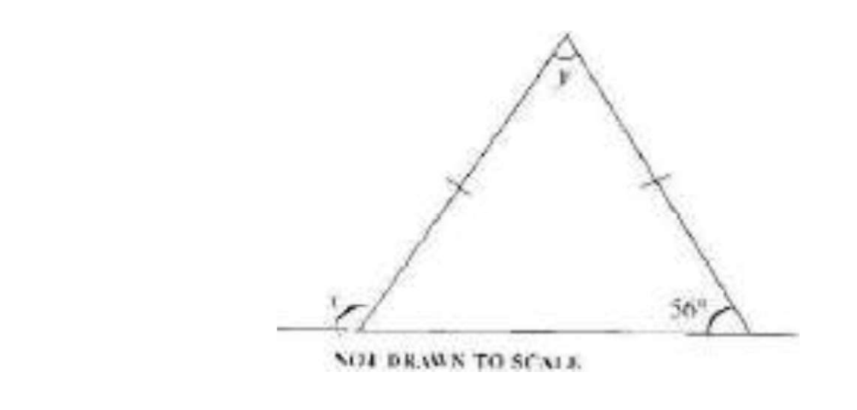
A. 68°.
B. 75°.
C. 112°.
D. 124°.
18. Find the value of y (using the diagram in Question 17).
A. 68°.
B. 75°.
C. 112°.
D. 124°.
19. A car used 8 hours to travel from town A to town B at a speed of 18 km/h. Find the distance travelled.
A. 22.5 km.
B. 135 km.
C. 140 km.
D. 144 km.
20. The pie chart shows the household budget of a family: Food 22%, Rent 28%, Others 16%, Entertainment 5%, Savings 3%, Clothing 11%, and Insurance and Taxes (unlabelled). (Use the information to answer Questions 20 and 21.) Find the angle for INSURANCE and TAXES.
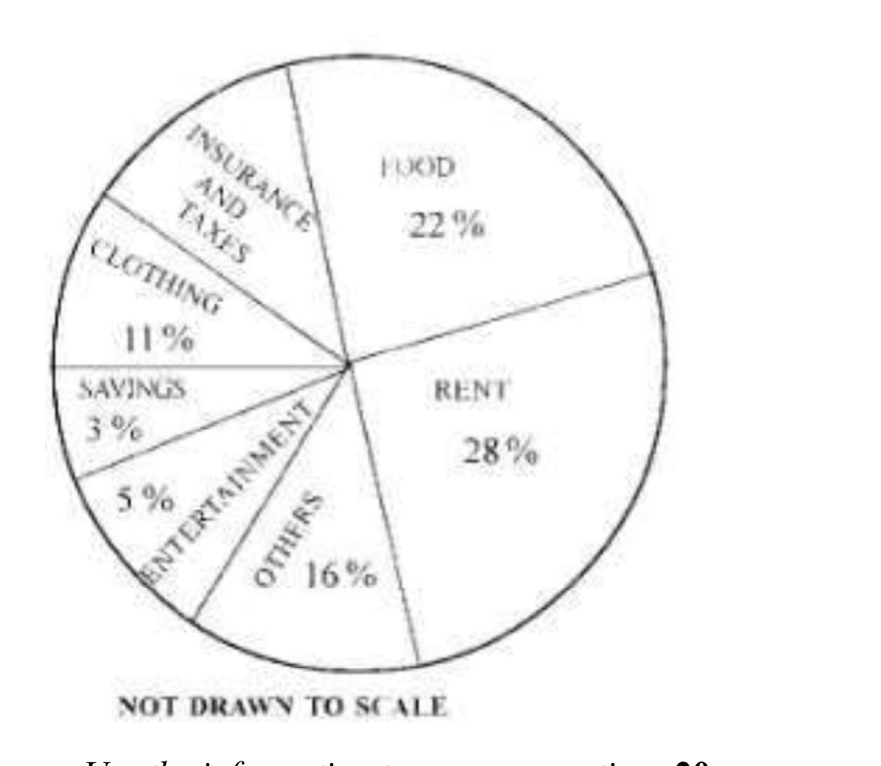
A. 45°.
B. 54°.
C. 60°.
D. 72°.
21. If the family's income was GHc 40,000.00, how much was spent on clothing?
A. GHc 1,600.00.
B. GHc 2,000.00.
C. GHc 3,200.00.
D. GHc 4,400.00.
22. Two sides of a parallelogram are 5.8 m and 8.2 m long. Find its perimeter.
A. 11.0 m.
B. 36.6 m.
C. 28.0 m.
D. 47.6 m.
23. A man earned an interest of GHc 240.00 in 4 years at 20% per annum simple interest. Calculate the principal.
A. GHc 300.00.
B. GHc 450.00.
C. GHc 480.00.
D. GHc 1,200.00.
24. A labourer worked for 20½ hours. If he was paid GHc 2.50 per hour, what was his total wage?
A. GHc 51.00.
B. GHc 51.25.
C. GHc 512.00.
D. GHc 512.25.
25. If 480 pupils in a school are boys representing 80% of the school's enrolment, find the total number of pupils in the school.
A. 384.
B. 540.
C. 600.
D. 864.
26. The mapping below shows the relationship between x and y:
x: 1 2 3 4
y: 2 5 10 17
What is the rule for the mapping?
A. x → 3x² − 1.
B. x → 5x − 3.
C. x → x² + 1.
D. x → 4x − 2.
27. In the diagram, MNO is a right-angled triangle with the right angle at N. MN = 5 cm, MO = 13 cm and NO = t cm. Find the value of t.
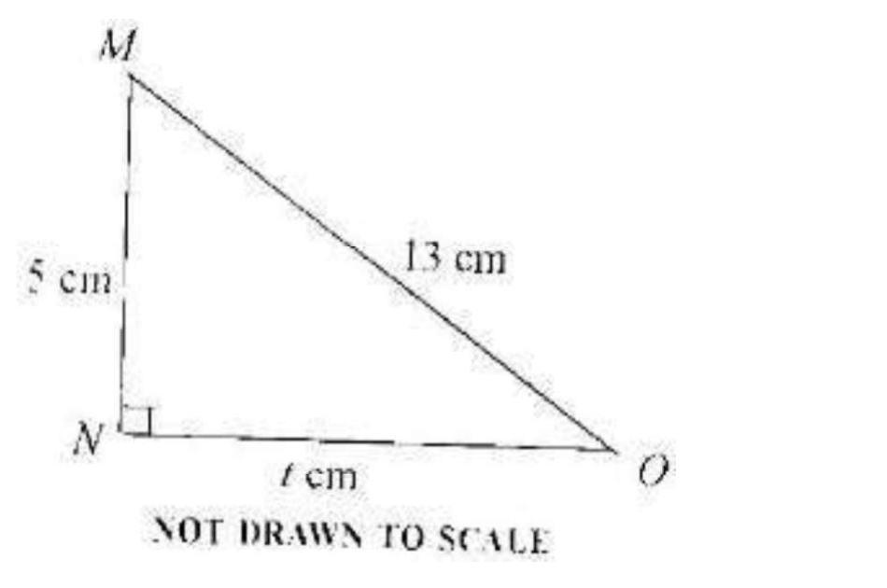
A. 12.
B. 8.
C. 4.
D. 3.
28. Add the following numbers: 2.4, 0.042, 1.12 and 0.342
A. 2.184.
B. 3.904.
C. 4.282.
D. 6.200.
29. Solve 4ˣ = 32.
A. 2 1/2.
B. 3 1/2.
C. 5.
D. 7.
30. Find the equation of the straight line passing through the points (−3, 5) and (6, 8).
A. y = 1/3x.
B. y = 1/3x + 6.
C. y = 3x − 10.
D. y = 3x − 14.
31. There are 15 females in a debating club. If the ratio of females to males is 3:2, how many members are in the club?
A. 6.
B. 10.
C. 22.
D. 25.
32. If P'(4, −5) is the image of P(x, y) translated by r = (−2, 3), find the values of x and y.
A. (−6, 8).
B. (−6, −8).
C. (6, −8).
D. (6, 8).
33. If 2y = 1 − 3x² + 4x, find y when x = −1.
A. −3.
B. −1/2.
C. 1/2.
D. 3.
34. Given that P = {1, 2, 3, 4, 5, 6, 7, 8, 9, 10, 11, 12}, what is the probability of selecting a prime number from the set?
A. 2/3.
B. 7/12.
C. 1/2.
D. 5/12.
35. Solve: 3 − (3x + 4) ≤ −4.
A. x ≤ 1.
B. x ≥ 1.
C. x ≥ 1 2/3.
D. x < 1 1/2.
36. Two sides of a rectangle are 10 cm and 6 cm. Calculate the area of a square with the same perimeter as that of the rectangle.
A. 16 cm².
B. 30 cm².
C. 60 cm².
D. 64 cm².
37. Make n the subject of the relation y = (n − x)/x.
A. n = x(y + 1).
B. n = y(x + 1).
C. n = x/(y − 1).
D. n = x/(y + 1).
38. Expand and simplify: (a − 2)(2a + 3).
A. a² − a + 6.
B. 2a² + 7a − 6.
C. 2a² − a − 6.
D. 2a² − 12a + 6.
39. Simplify: 2² × 2⁷ ÷ 2⁴.
A. 2⁻¹.
B. 2⁵.
C. 2¹¹.
D. 2¹³.
40. If P = {7, 11, 13} and Q = {9, 11, 13}, find P∪Q.
A. {7, 9, 11, 13}.
B. {7, 9}.
C. {11, 13}.
D. {9, 13}.

Answer Key
1. B 1/2.  2. D { }.  3. D 4.38293 × 10³.  4. C Distributive.  5. C 8 − 10x.  6. C GHc 4.57.  7. D −2 < y ≤ 2.  8. D 12a⁵b⁵.  9. C Trapezium.  10. B GHc 67.00.  11. A 6.  12. D 7.  13. C (2, 3).  14. B 6/7.  15. C 11.  16. A 3/2.  17. D 124°.  18. A 68°.  19. D 144 km.  20. B 54°. | 21. D GHc 4,400.00.  22. B 36.6 m.  23. A GHc 300.00.  24. B GHc 51.25.  25. C 600.  26. C x → x² + 1.  27. A 12.  28. B 3.904.  29. A 2 1/2.  30. B y = 1/3x + 6.  31. D 25.  32. C (6, −8).  33. A −3.  34. D 5/12.  35. B x ≥ 1.  36. D 64 cm².  37. A n = x(y + 1).  38. C 2a² − a − 6.  39. B 2⁵.  40. A {7, 9, 11, 13}.

